Site Configuration of a WebBrick Gateway

General Setup Steps which will have to be carried out prior to following the steps of this guide include.

Network Interface Setup of Gateway
DNS Setup - to resolve domain names
NTP Setup - to receive time updates
Hosts Setup - to allow Webbricks to be discovered

Tools we advice you to have on your machine are:
- Notepad++ or Textpad
- FileZilla
- Cygwin Toolkit (for sed)
Step 1 – Get Site Configuration:

Chapter 1: Heating
Configuring the zone heating requires editing of the following files:
- hvac.xml
- Input and Output file per zone
- Input and Output file per Zonegroup
- Input and Output file per Heatsource (copy relevant template from template_files)
- Input and Output file for Zone Master
- Input and Output file for Weather compensation
The required edits are small, only involving a few characters in most cases. The following videos will illustrate what edits are required in each file, whilst the figure below illustrates the heating arrangement the video tutorials are based on.

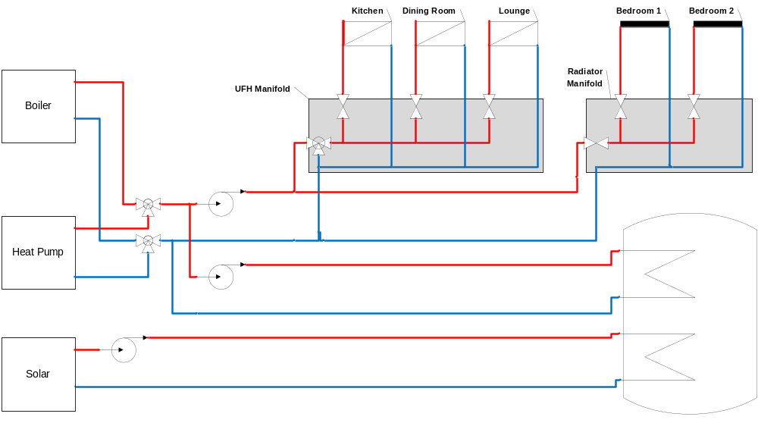

Chapter 2: Creating UI Zones
The UI is based on Zones and Functions in a property and initially both zones and functions that are available have to be specified.
File: zone_lists.kid
Path: /opt/webbrick/site/tempalate/round
The following video tutorial will describe how to edit the file to create the UI zones and their functions for a site with the following zones with the listed functions:
Zone | Audio | Lighting | Video | Security | Heating | Ventilation
Kitchen | X | X |  |  | X | X
Dining Rm | X | X |  |  | X
Lounge | X | X | X |  | X
Bedroom 1 | X | X |  |  | X
Bedroom 2 | X |  |  |  | X
Hall |  | X
Bathroom |  | X |  |  |  | X
Gate |  |  |  | X
Outside |  | X |  | X

For this follow AN030 – Configure Heating
Configure Functionality per Zone

Definition: A property is generally split into zones, these zones are not functional areas, but physical areas. Lighting, heating, ventilation, AV and security are displayed on a Zone by Zone basis on the Gateway UI.

Sample list of Zones:

Kitchen
Bathroom 1
Bathroom 2
Bathroom 3

